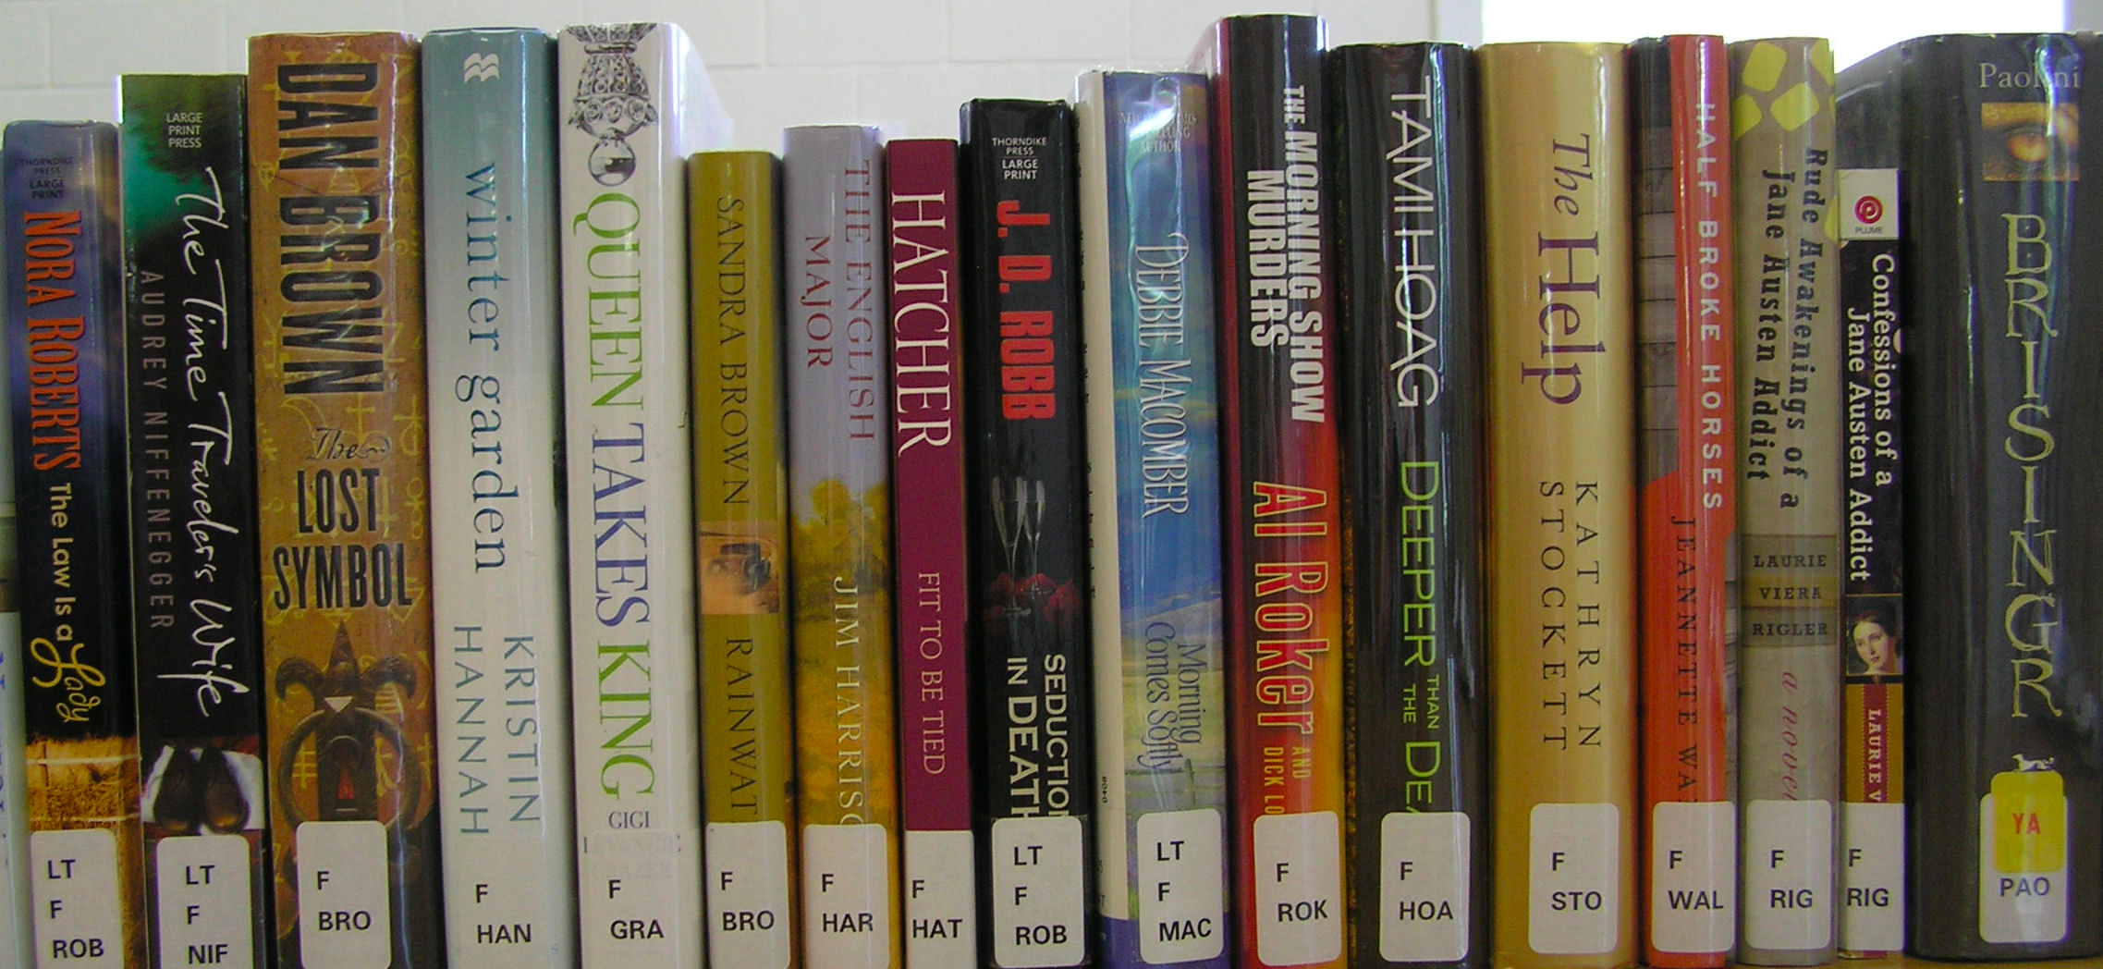

Independent Reading
Requirement
2nd Nine Weeks

For the second nine weeks, students will be responsible for reading at least 400 pages independently. Books may be from any genre, but need to be within his/her reading range as appropriate for grade level and content. Students are allowed to read as many books as needed to achieve the required 400 pages.

Part1) You are required to answer at least 4 Response Questions from the sheet for each book you read. Once you answer these questions, you may no longer answer them for any books read afterwards. So if you choose question #1, you can’t use that question ever again. Your answer to the question should be at least 5 complete sentences. These questions are meant to make you stop and think about what you read. There are no right or wrong answers. Your points for this section are based on how much thought you put into your response and how well you explain/support your ideas.

Part 2) In addition to your questions, you are also required to complete a summary of the book you read. You should follow the order of the plot diagram, making sure you include details from every part of the plot (exposition, rising action, climax, falling action, resolution and identifying the conflict). Your summary should cover at least the front of a piece of notebook paper.

Because it is vital that students read on their own, independent reading will be considered a single-weighted test grade.

All questions and your summary must be completed and turned in by December 12 , 2016 for first nine weeks credit. There are no “rollover” pages, so any amount of pages read above 300 during the first nine weeks will stay with the first nine weeks.

Mr. Knowlton

8th Grade Language Arts
Avalon Middle School

